THIRD SEMESTER PROJECT

Online Aptitude Test -
User Guide

Date of Submission: 02-NOV-2023

Submitted By:

Student NameIDAbdul Rehman Siddiqui1336545Balaj Ahmed Khan1335831Ashhad Khan1335849Muhammad Rameez1336479

Add Category

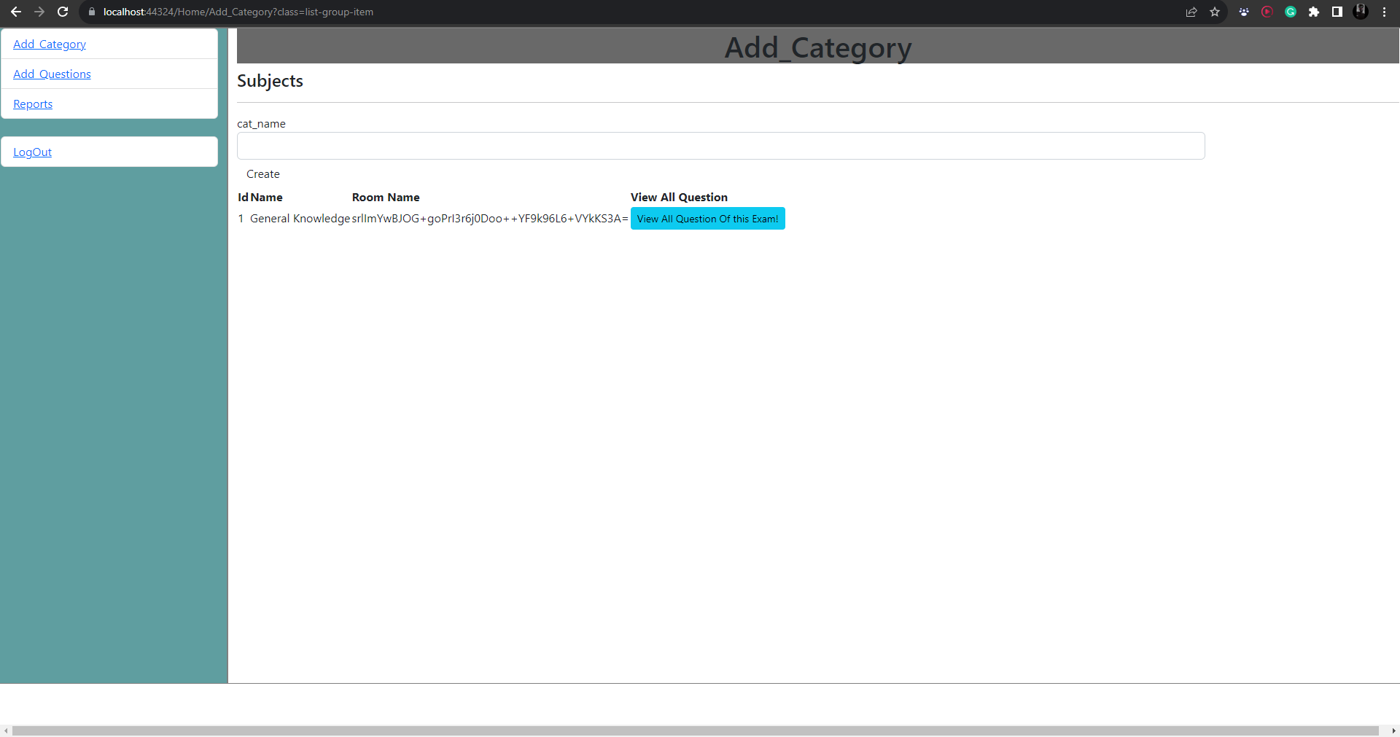

Add Questions

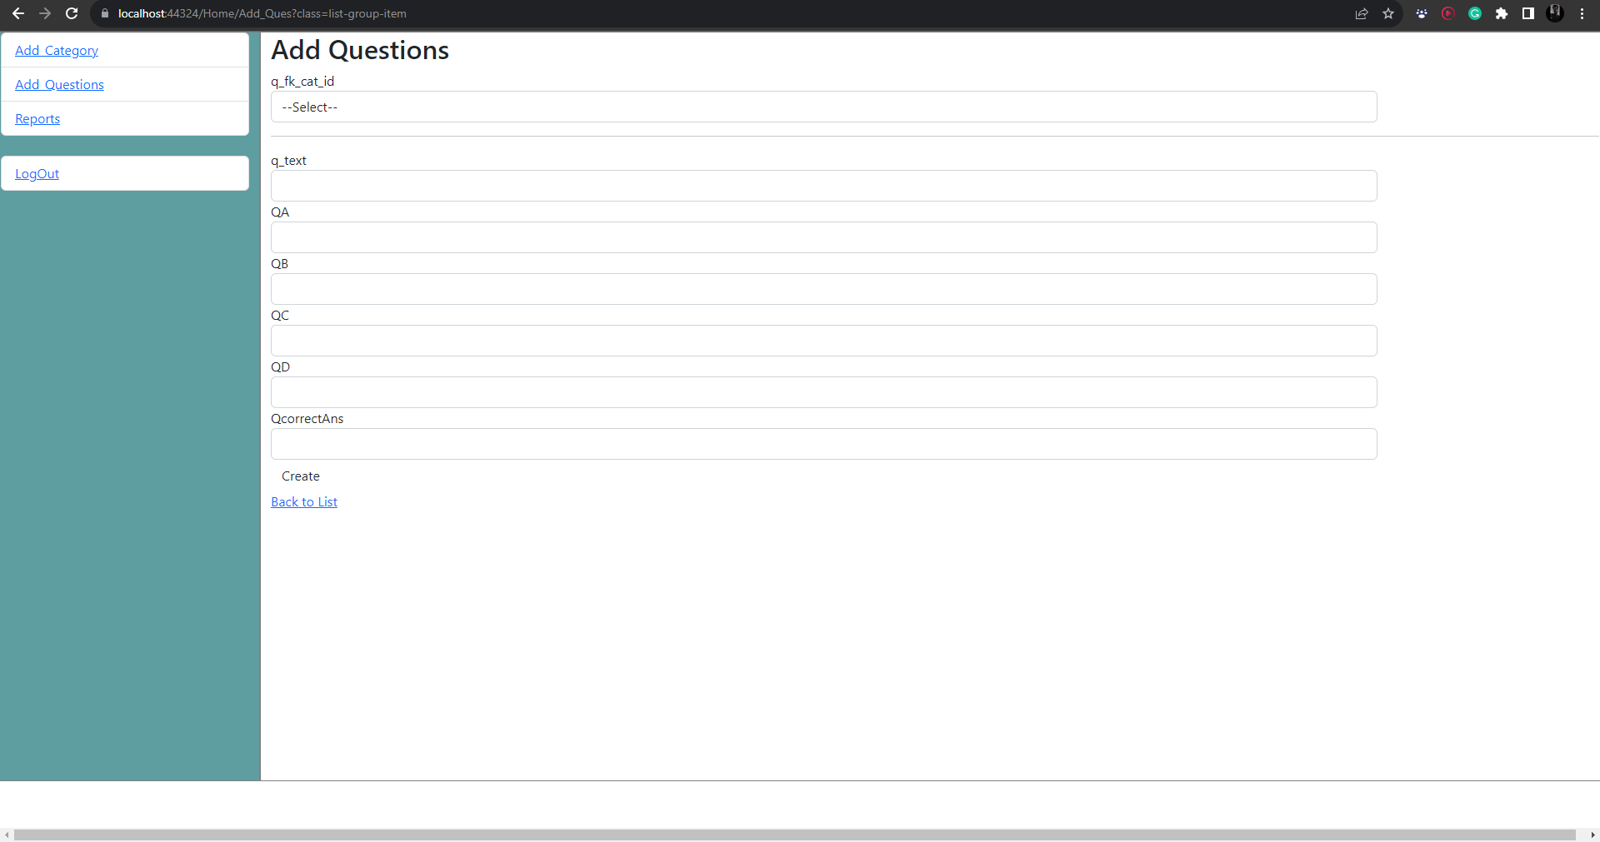

Admin Dashboard

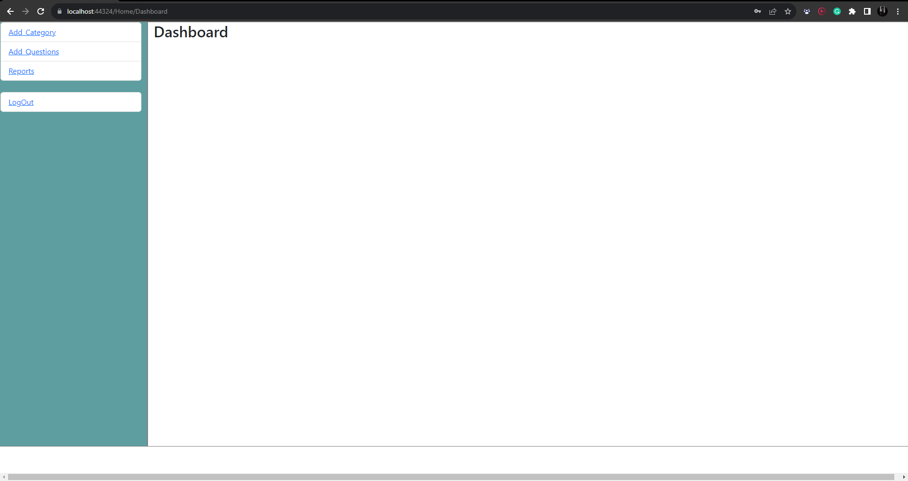

Admin Login

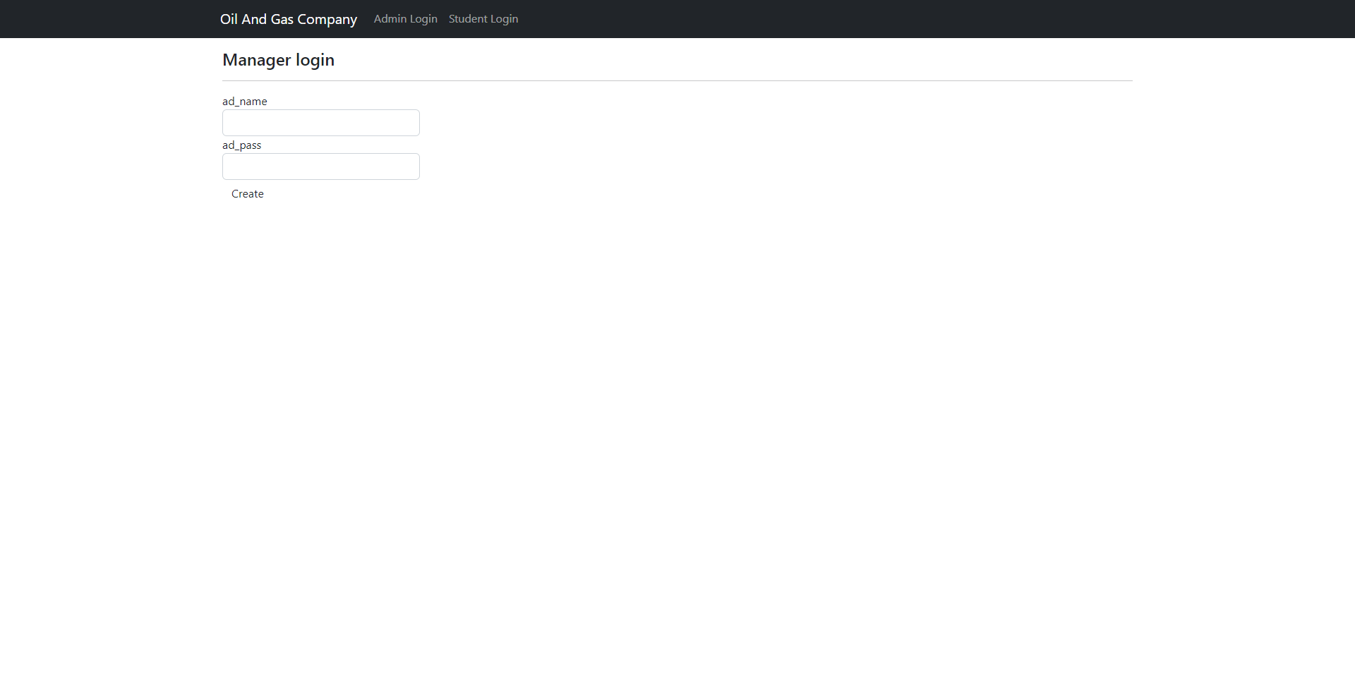

Database Diagram

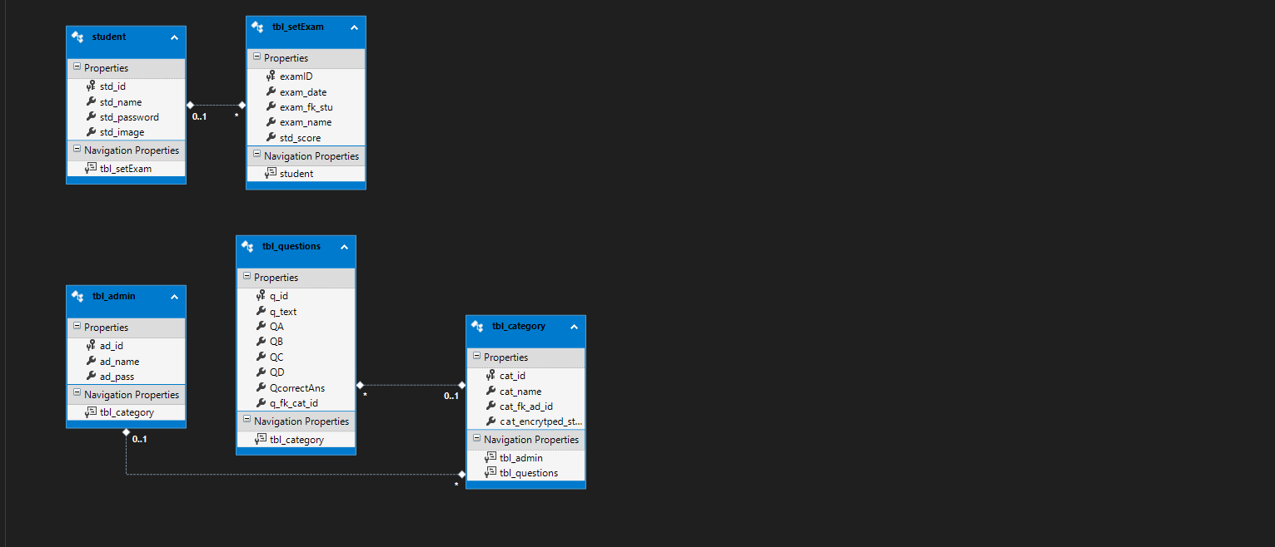

Home Page



Roll Number

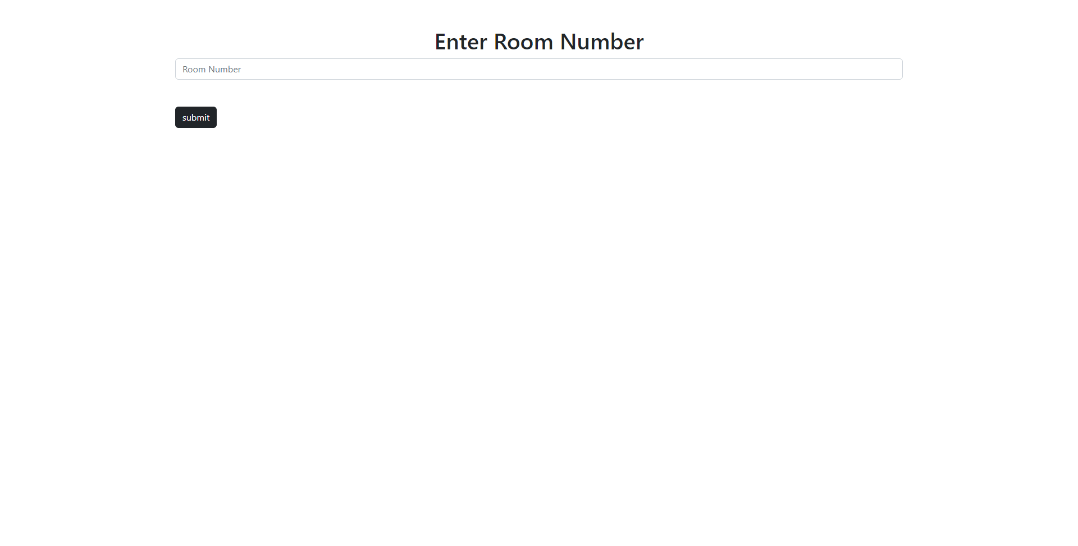

Student Login

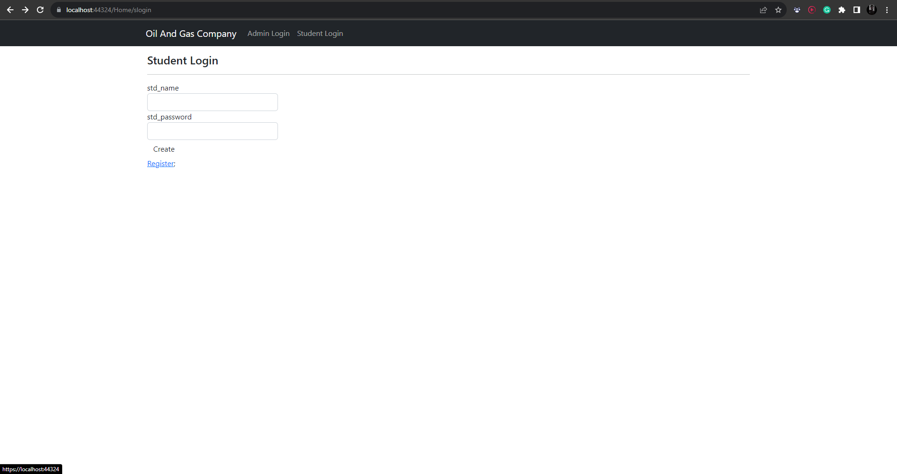

Student Registration

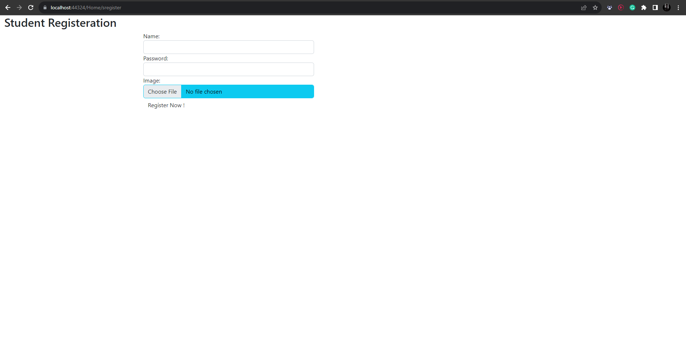

All Question

